**Program No.1(A): Write a JavaScript program to calculate area of Triangle**

//Program: To find Area of Triangle

<!DOCTYPE HTML>

<html>

<head>

<meta http-equiv="Content-Type"

content="text/html; charset=utf-8">

<title>

JavaScript function to find

the area of a triangle

</title>

</head>

<body style="text-align: center;">

<h1 style="color: green;">

E&TC Department AVCOE

</h1>

<h4>

JavaScript function to find

the area of a triangle

</h4>

<label for="side1">

Enter the value of side 1:

</label>

<input type="number" id="side1"

placeholder="Enter value of side 1">

<br><br>

<label for="side2">

Enter the value of side 2:

</label>

<input type="number" id="side2"

placeholder="Enter value of side 2">

<br><br>

<label for="side3">

Enter the value of side 3:

</label>

<input type="number" id="side3"

placeholder="Enter value of side 2">

<br><br>

<button onclick="Area()">Click Here!</button>

<p>

Area of Triangle: <span id="display"></span>

</p>

<script type="text/javascript">

function Area() {

var side1 = parseInt(document

.getElementById("side1").value);

var side2 = parseInt(document

.getElementById("side2").value);

var side3 = parseInt(document

.getElementById("side3").value);

console.log(typeof(side1));

var s = (side1 + side2 + side3) / 2;

var area = Math.sqrt(s * ((s - side1)

* (s - side2) * (s - side3)));

document.getElementById(

"display").innerHTML = area;

}

</script>

</body>

</html>

**Output:**

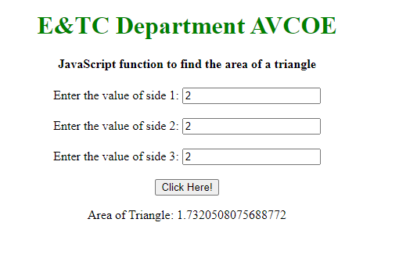

**Program No.1(B): Write a JavaScript program to calculate area of Rectangle**

<!DOCTYPE HTML>

<html>

<head>

<meta http-equiv="Content-Type"

content="text/html; charset=utf-8">

<title>

JavaScript function to find

the area of a rectangle

</title>

</head>

<body style="text-align: center;">

<h1 style="color: green;">

E&TC Department AVCOE

</h1>

<h4>

JavaScript function to find

the area of a rectangle

</h4>

<label for="Length">

Enter the value of Length:

</label>

<input type="number" id="Length"

placeholder="Enter value of Length">

<br><br>

<label for="Width">

Enter the value of Width:

</label>

<input type="number" id="Width"

placeholder="Enter value of Width">

<br><br>

<button onclick="Area()">Click Here!</button>

<p>

Area of Rectangle: <span id="display"></span>

</p>

<script type="text/javascript">

function Area() {

var Length = parseInt(document

.getElementById("Length").value);

var Width = parseInt(document

.getElementById("Width").value);

console.log(typeof(side1));

var Area = (Length * Width) ;

document.getElementById(

"display").innerHTML = Area;

}

</script>

</body>

</html>

**Output:**

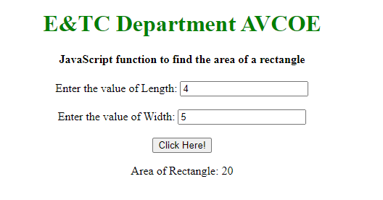

**Program No.1(C): Write a JavaScript program to calculate area of Circle.**

<!DOCTYPE HTML>

<html>

<head>

<meta http-equiv="Content-Type"

content="text/html; charset=utf-8">

<title>

JavaScript function to find

the area of a circle

</title>

</head>

<body style="text-align: center;">

<h1 style="color: green;">

E&TC Department AVCOE

</h1>

<h4>

JavaScript function to find

the area of a circle

</h4>

<label for="radius">

Enter the value of radius:

</label>

<input type="number" id="radius"

placeholder="Enter value of radius">

<br><br>

<button onclick="Area()">Click Here!</button>

<p>

Area of Circle: <span id="display"></span>

</p>

<script type="text/javascript">

function Area() {

var radius = parseInt(document

.getElementById("radius").value);

console.log(typeof(side1));

var Area = (3.14 * radius * radius);

document.getElementById(

"display").innerHTML = Area;

}

</script>

</body>

</html>

**Output:**

